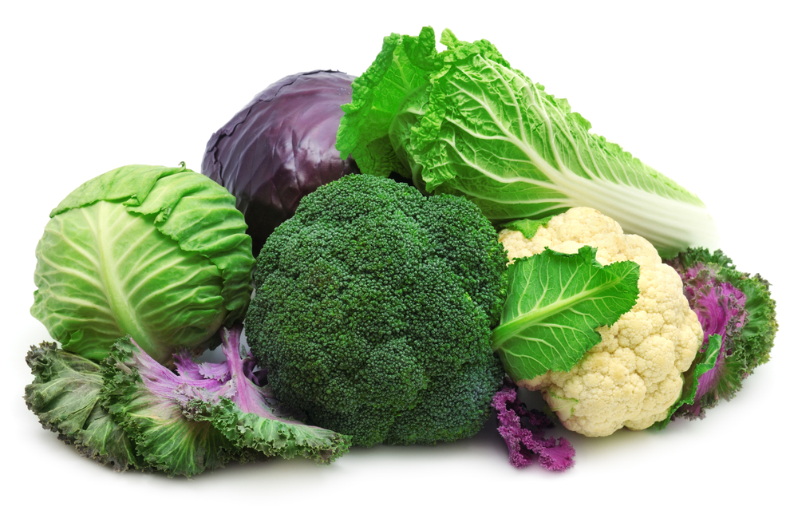

Complete List of Cruciferous Vegetables.

Arugula
Bok choi
Broccoli
Broccoli rabe
Broccoli romanesco
Brussels sprout
Cabbage
Cauliflower
Chinese broccoli
Chinese cabbage
Collard greens
Daikon
Garden cress
Horseradish
Kale
Kohlrabi
Komatsuna
Land cress
Mizuna
Mustard – seeds and leaves
Pak choi
Radish
Rutabaga
Tatsoi
Turnips – root and greens
Wasabi
Watercress

