

When we reach a plateau and our body fat doesn’t drop despite eating a high protein diet, low carbs, no sugar and working out 5- 6 days a week, it can be a bit discouraging to continue to work out.

One of my go to plans it have a re-feed day or fun/flex/feast day to change things up. Give this a try at least once a week and follow the guidelines.

Strategies for preventing fat gain on your fun/flex/feast day

- Workout in the morning and get your target heart rate up with interval training – use the formula (220 – age) X 83% gives you target heart rate. E.g. 50 year old is (220-50) X .83= 141
- Take Beta alanine (750 mg) before your workouts and make sure you sweat
- Prior to meals take the following supplements – 300 mg Alpha-lipoic acid, Green tea flavonoids (must be 325 mg of EGCG), and 200 mg Garlic Extract

- Your first meal of the day is not a binge meal. Have at least 30 grams of protein and insoluble fiber (legumes are a good choice, I usually consume ½-1 cup beans).
E.g. Eat a big breakfast like eggs, beans, bacon or sausage – at least 30 grams of protein, 7 -10 grams of fiber
- 1 hour after your breakfast consume 1/2 grapefruit – not recommended if you are taking blood pressure medication. As crazy as this sounds you can put some grapefruit juice in your coffee to stimulate the effect of caffeine and increase fat burning. Grapefruits contain naringin, a flavonoid that lowers cholesterol and raises antioxidant activity.
- Do your quick short burst of squats, half jacks, pushups or wall push ups (about 30-50 reps) for 60-90 seconds 30 minutes before your fun/flex/feast meal AND 60-90 minutes after your meal so that the carbs, sugar are not stored as fat; it’s helpful to do this throughout the day too.
- Drink citrus drinks, green tea, yerba mate tea throughout the day to minimize the release of insulin
- Prior to bed take 20 grams of policosanol, 300 mg alpha-lipoic acid, 200 mg Garlic Extract

Sample 24 hour day of a flex/fun/feast day

Morning
Upon Rising drink 16 ounces of water
Workout for 20-30 minutes strength training and cardio in target heart of 83%
Prior to breakfast take Alpha Lipoic Acid, Garlic Extract, Green Tea Extract
Eat a big breakfast as usual
1 hour after breakfast eat ½ grape fruit

Lunch
30 minutes prior to feast do 60-90 seconds of squats, half jacks, push ups or wall push ups
Prior to fun/flex/feast meal take Alpha Lipoic Acid, Garlic Extract, Green Tea Extract
Feast meal!!!
60 minutes after feast do 60-90 seconds of squats, half jacks, push ups or wall push ups

Dinner
30 minutes prior to feast do 60-90 seconds of squats, half jacks, push ups or wall push ups
Prior to fun/flex/feast meal take Alpha Lipoic Acid, Garlic Extract, Green Tea Extract
Feast meal!!!
60 minutes after feast do 60-90 seconds of squats, half jacks, push ups or wall push ups

Throughout day drink lemonade, green tea, coffee or yerba mate tea

Bedtime
Take Alpha Lipoic Acid, Garlic Extract, Policosanol

The following supplement are available at Mother’s Market, Whole Foods or Sprouts
(except Allicidin/garlic brand – you may choose any Brand)

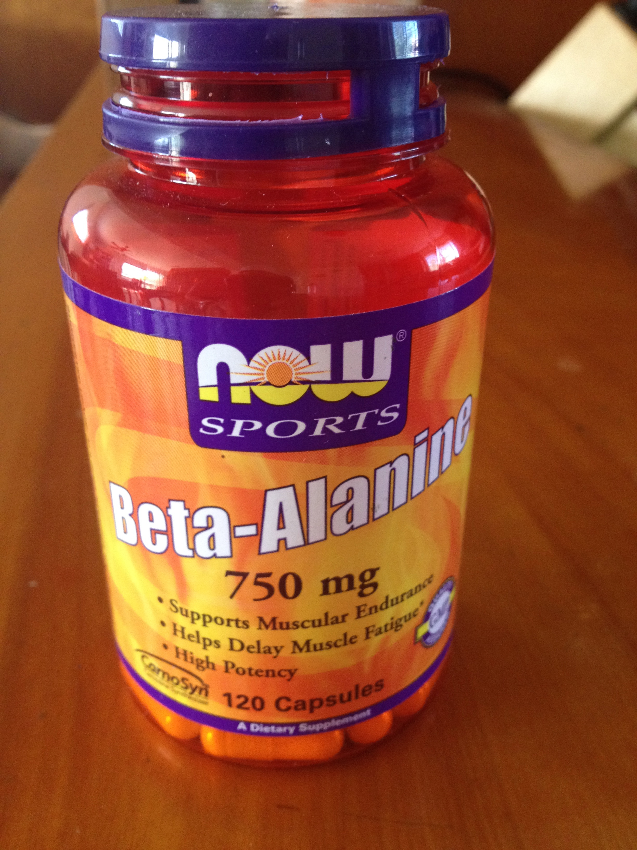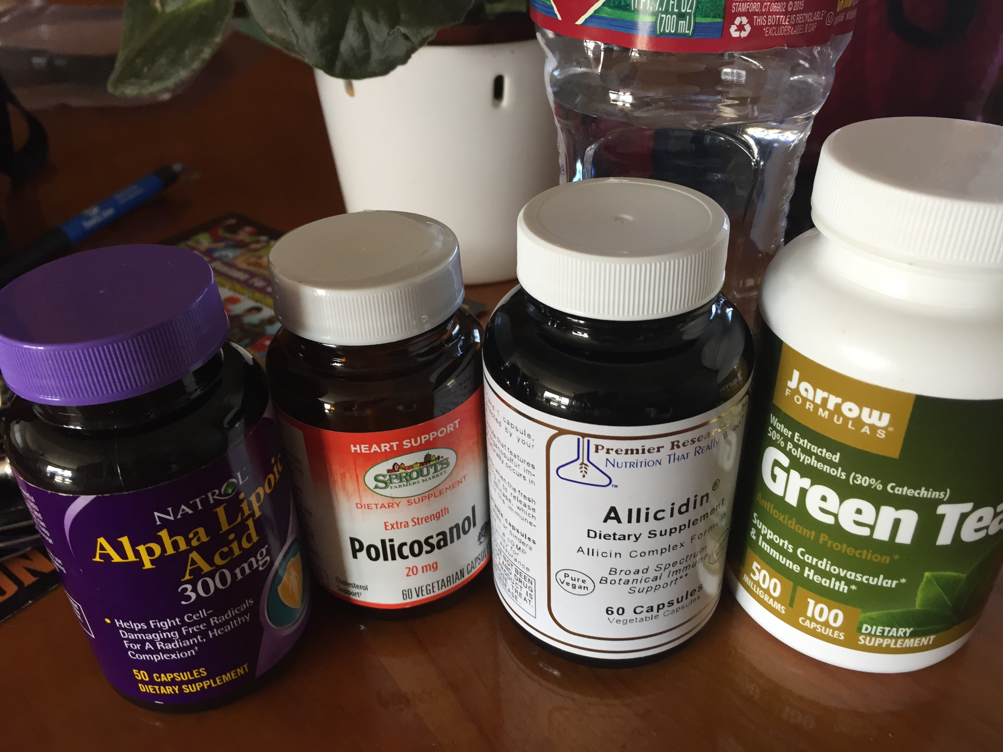

The Most Common Mistakes During the Accelerated Fat Burning Plan

- Skipping breakfast or not eating breakfast within 30-60 minutes of waking – this is the most common mistake and why people fail when it comes to burning fat and healing. This is most common with women who have hormone imbalance and are not fat adapted. Most men can get away with not eating breakfast after they get their body fat adapted.

- Eating food not on the list – the foods on the list are foods that will help with optimizing hormone harmony to burn fat, have more energy, look younger and minimize mood swings; and yes even fruits can do this (heard of a fruit belly?)

- Not drinking enough water – adequate water is necessary in order for optimal liver function. The liver is vital for fat burning, detoxification, hormone clearance and blood sugar stabilization

- Not eating enough protein – it’s important to get in at least 30 grams of protein for breakfast and 20 at lunch and dinner. Other than animal products additional protein options are plant based smoothie and whey protein (from grass fed cows) if you have not tested positive to whey.

- Working out too much – over training can put stress on your adrenal glands and inhibit fat burning and even lead to overeating; it can also lead to injuries which can kick you out of fat burning

- Eating too much nuts – since a handful or ¼ cup of germinated nuts or seeds are permitted to zest up your salads or in case of a desperate emergency when you are away from home and did not get a chance to plan properly

- Poor planning – it is vital to know what your meals are and plan them at least 24 hours in advance or even for the week

- Not enough or poor sleep – the magic occurs when you sleep; if you are sacrificing sleep, getting up several times to urinate or not getting to bed by 10pm, this will affect your progress

- Not taking a day off – having a fun/flex day, carb loading is necessary to reset your body, kind of like shocking the system

- Eating too late (last meal should be 6-7 pm at the latest)

- Not fasting for 12 hours between last meal and breakfast

